

CHALLENGE NAME: [Aria of the Lost Code]   
DEV : [Abhinav]

CATEGORY: [Cryptography]   
LEVEL: []

2025



CHALLENGE NAME: [Aria of the Lost Code]

**Challenge Description**:   
A shattered data shard from an ancient relic has been recovered. It hums with a cryptic resonance, revealing a fragmented inscription in an unknown script. After intense decryption efforts, a single phrase emerged:

"The melody echoes beyond the void."

Can you uncover the true message hidden within?  
Flag Format:

**VishwaCTF{A4v4_a4a_4aa4a_Aa_44a4a4a4}**

**Solution:**The Given Image from the **Hymnos Alphabet** you can find that easily at sites like decode.fr.  
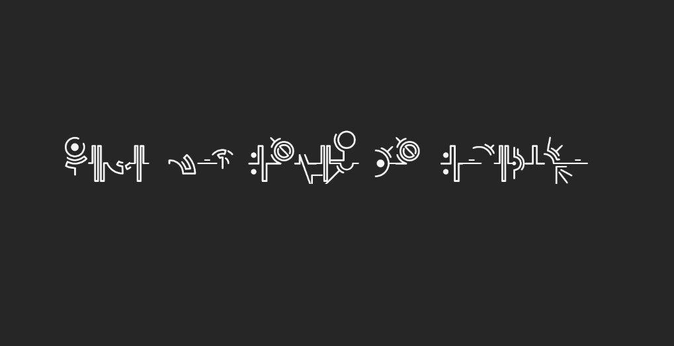

Using Decode.fr site we can decode the cipher:  
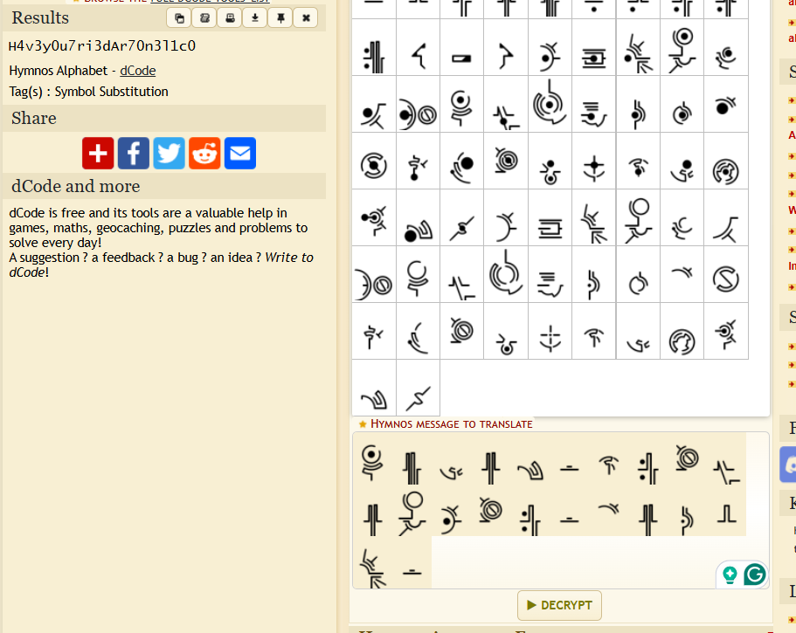

**Flag: VishwaCTF{H4v3_y0u_7ri3d_Ar_70n3l1c0}**

DEV: [] **1**